**Assignment – 3: (Pijush Ghosh)**

* **Use the Employee Details dataset and perform the following activities: -**
* *Split the column CITY and separate the code associate with each city like - Allahabad[AL2] should be only Allahabad and [AL2] will be separate.*
* *Extract the first name from EMPLOYEE NAME column and transform the column.*
* *Using the JOINING DATE column extract the Year and no. of days for that month*
* *Create a visual of your choice and show the how much salary has been paid to each state and which state has lowest payout.*

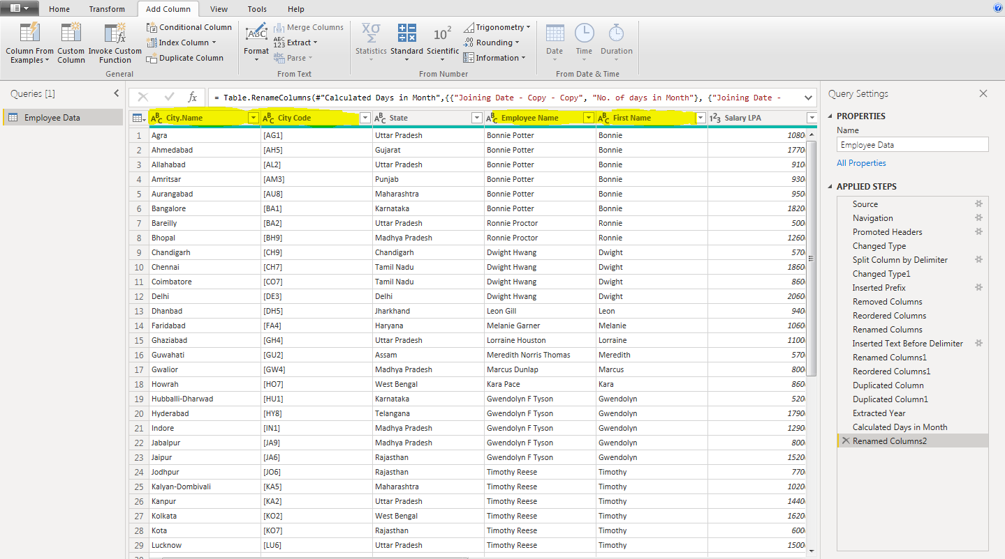

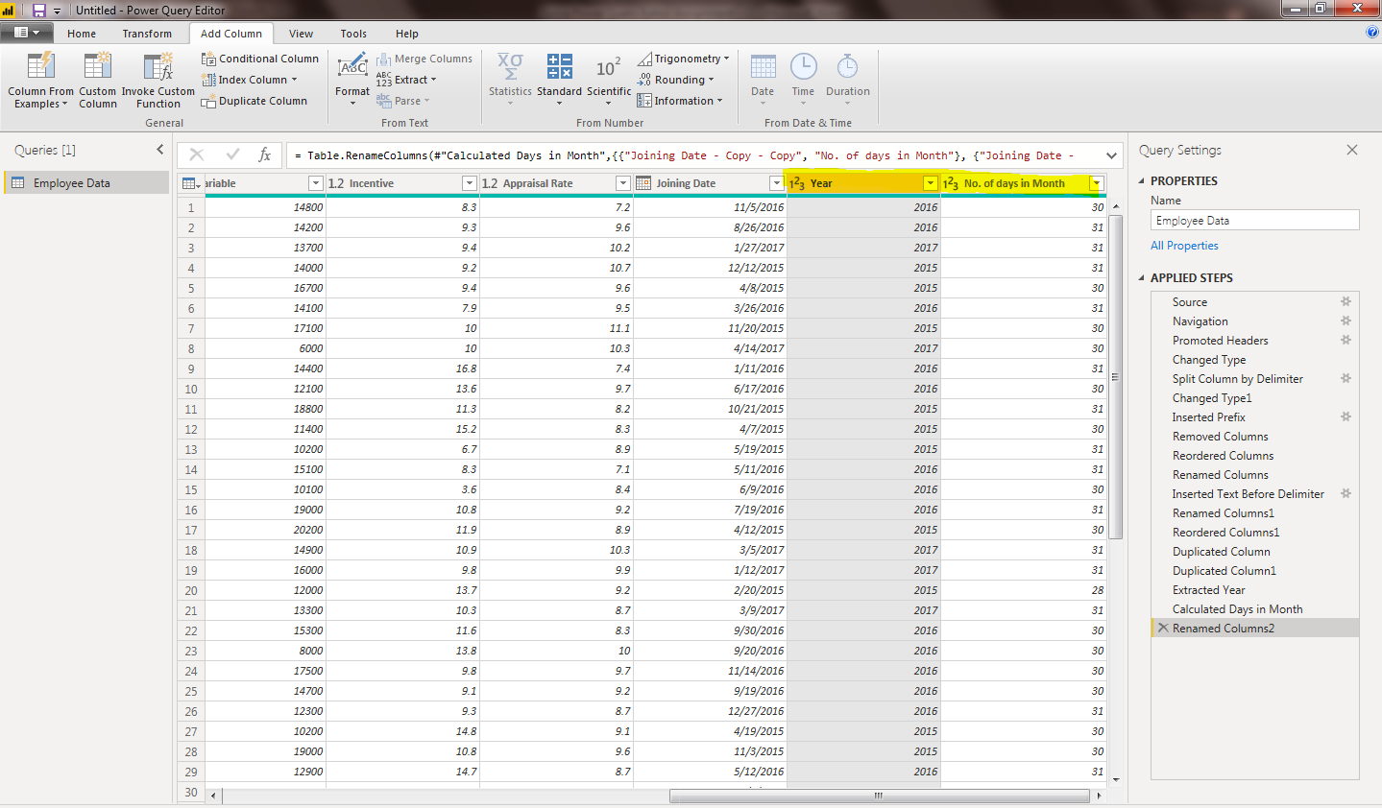

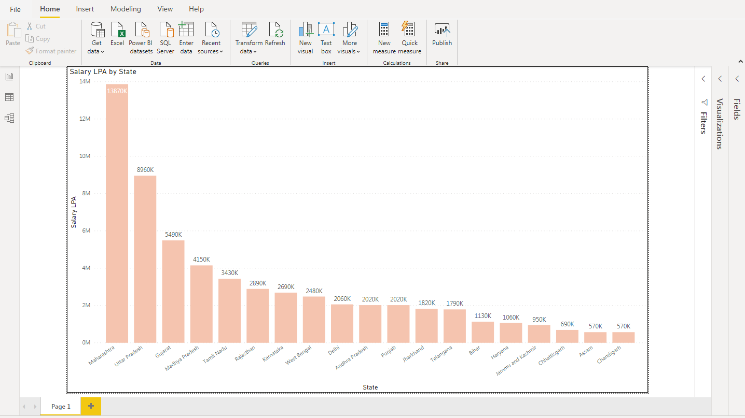

The ‘Assam’ and ‘Chandigarh’ have lowest payout i.e. 570K